PARTNERS IN ASIA

CAMBODIA   | French-Cambodian Chamber of Commerce  Contact: Mr Denis Gambade  Phone: +855 12 801 950  Fax: +855 23 221 453  E-mail: ccfc@online.com.kh  Web-site: www.ccfcambodge.org
CHINA   | Beijing Chao Yang Tourism Industry Association  Contact: Mr. Niu Yu Hong  Phone: +86 010 65099081  Fax: +86 010 65099076  E-mail: contact@bjta.gov.cn  Web-site: http://english.bjta.gov.cn/
NEPAL  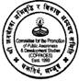 | Committee for the Promotion of Public Awareness and Development Studies (COPPADES)  Contact: Mr. Dikendra Raj Kandel  Phone: +977 1 4353873  Fax: +977 1 4380009  E-mail: coppades@ntc.net.np  Web-site: www.coppades-nepal.org
PAKISTAN   | Woman Empowerment Literacy and Development Organisation  (WELDO)  Contact: Ms. Iram Masud  Phone: +92 51 5590475  Fax: +92 51 5590 475  E-mail: weldo@weldo.org  Web-site: www.weldo.org
VIETNAM   | Chambre de commerce et d’Industrie Française au Vietnam  Contact: Mr. Nicolas Bonnardel  Phone: +84 8 997 39 28  Fax: +84 8 997 48 27  E-mail: nicolas.bonnardel@ccifv.org  Web-site: www.ccifv.org

PARTNERS IN EUROPE

ESTONIA  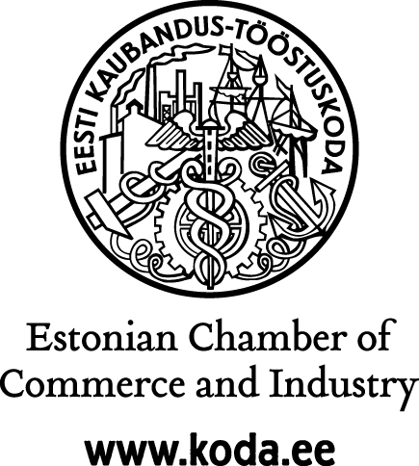 | Estonian Chamber of Commerce and Industry  Contact: Ms. Liis Liivoja  Phone: +372 604 0081  Fax: +372 604 0061  E-mail: liis@koda.ee  Web-site: www.koda.ee
FRANCE   | Association Française d’Ecotourisme  Contact: Mr. Pascal Languillon  Phone: +33 561 2322 59  Fax: +33 676 2693 55  E-mail: pascal@ecotourisme.info  Web-site: www.ecotourisme.info
GERMANY   | ConnectAsiaEurope e.V. (CAE)  Contact: Mr. Volker Lehmache  Phone: +49 (0) 228 289 20 15  Fax: +49 (0) 228 289 20 14  E-mail: lehmacher.volker@bhk-international.de  Web-site: www.cae-ev.de
GREECE  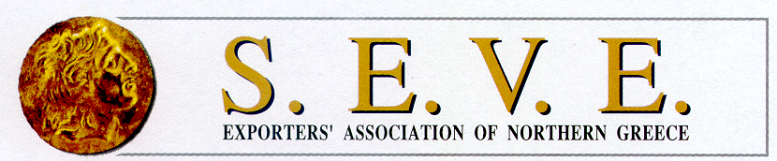 | Exporters’ Association of Northern Greece (S.E.V.E.)  Contact: Ms. Eftichia Christaki  Phone: +30 2310 535333  Fax: +30 2310 543232  E-mail: ex@seve.gr  Web-site: www.seve.gr
ITALY  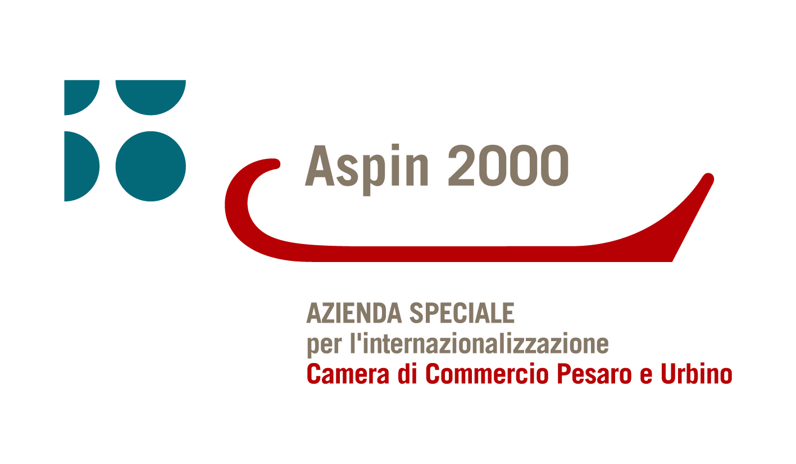 | A.SP.IN.2000  Contact: Ms. Gisella Bianchi  Phone: +39 0721 371343  Fax: +39 0721 33049  E-mail: aspin@aspin2000.it  Web-site: www.aspin2000.it

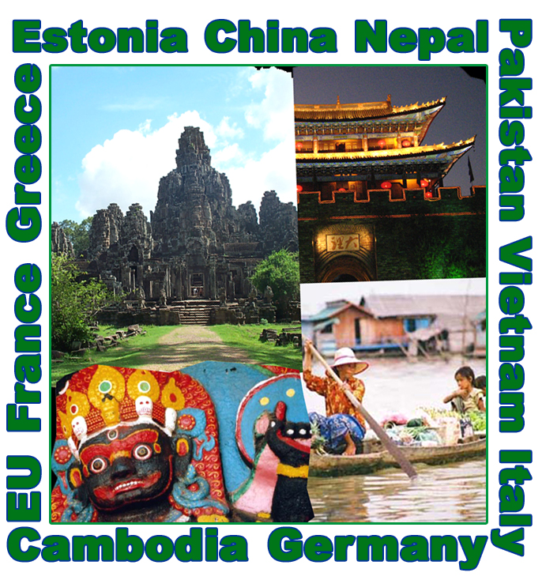

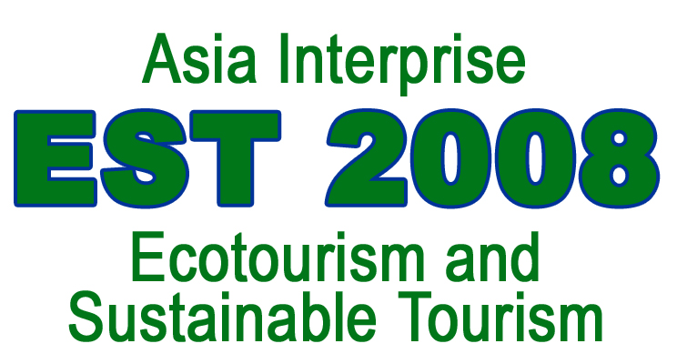

www.italasia.it/est2008

